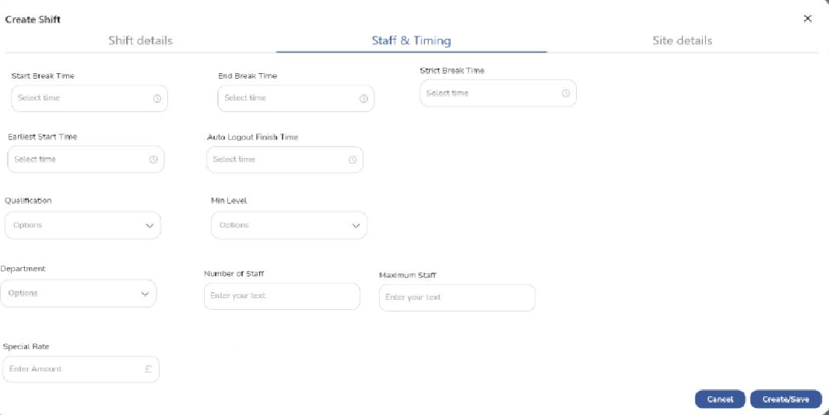

**Strict Break times**

Toggel or tickbox with **help as follows**

Strict Breaktime will only show the “start Break” and Start Lunch” buttons on the staff app between the specified times.

If not selected app will allow Start Breaks any time but if outside the specified times then it will be highlighted on the timesheet.

**Earliest Start time / Auto logout**

Remove these no needed

Below 3 sections can be done via a wizard or dropdowns. Shoh your ideas will be useful here.

**Qualification and Staff**

This is a small wizard as follows activated By “add Qualification Button”

1. Pick from available qualifications.
2. Pick “Minimum Level” from available levels for the above qualification
3. Enter number of staff needed with this qual
4. Add button. This puts above in a list with option to delete

For additional qualifications Same as above except after step 3 *Can be an alternative to :* select from one of the already created list.

For Toggel Help as Follows

Alternative will allow any of the listed Qualifications whereas Additional will require All the listed qualifications.

**Number of Staff**

This is a small wizard as follows activated By “Add Staff Requirement”

1. Select **Department**
2. Select **Number of Staff**
3. Add **Maximum Number of Staff**
4. Add button. This puts above in a list with option to delete.

**Special rate**

This is a small wizard as follows activated By “Add Special Rate”

1. Enter **name** (in the box can say (e.g. Out of hours, Overtime, Emergency Callout etc)
2. Select **Special Rate** (**Help**. hourly rate for staff)
3. Add **Fixed Hours** (**Help.** Paid hours regardless of actual hours worked)
4. Toggle **Split Time . (Help.**  Hours split equally between staff assigned to the shift)
5. Add button. This puts above in a list with option to delete.